TC003-STEP 1: Klik Button Create Ticket

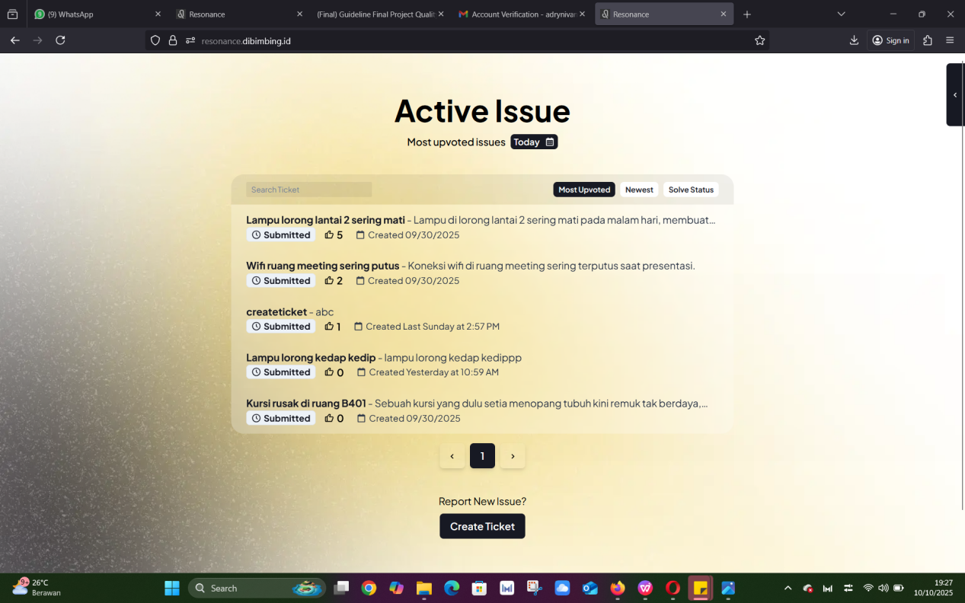

EXPECTED RESULT:

